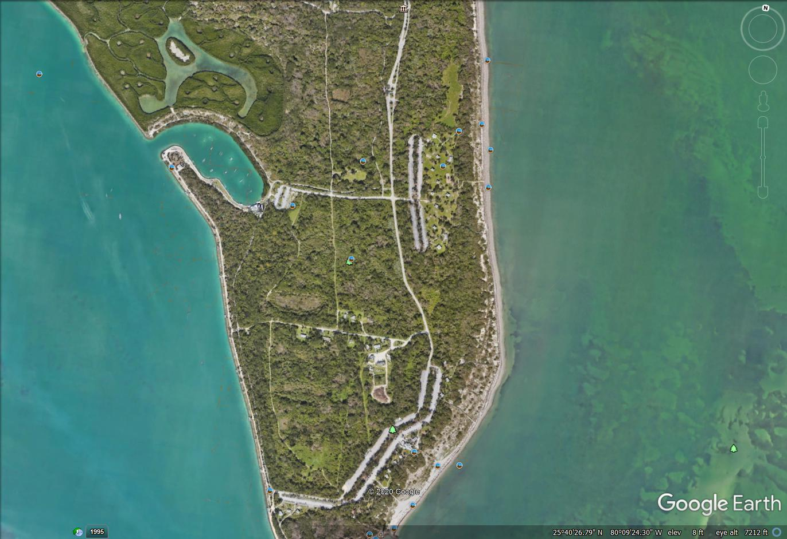

Area A Parking lots

Area B Parking lots