Table of Contents

**U.S. Department of Health and Human Services**

**Office of the Assistant Secretary for Preparedness and Response**

**Coronavirus Disease 2019**

**Fatality Management Tabletop Exercise**

**Situation Manual**

**March 2020**

Handling Instructions 3

Section 1: Exercise Overview 4

Section 3: Exercise Scenario 9

Section 3: Discussion Questions 17

Appendix A: Acronyms and Abbreviations A-1

# Handling Instructions

1. The title of this document is the *Coronavirus Disease 2019 Fatality Management Tabletop Exercise Situation Manual.*
2. For more information about the exercise, please email: [ASPRExercises@hhs.gov](mailto:ASPRExercises@hhs.gov).

# Section 1: Exercise Overview

## Background

The federal government is actively responding to a nationwide outbreak of a respiratory disease caused by a novel (new) coronavirus (abbreviated “COVID-19”)[1] that was first detected in Wuhan City, Hubei Province, China and continues to spread across the globe. On January 31, 2020, the President declared a Public Health Emergency, and on February 29, 2020, the World Health Organization declared COVID-19 a global pandemic. Two weeks later, on March 13, 2020, the President declared a National Emergency under the Robert T. Stafford Disaster and Emergency Assistance Act due to the widespread sustained community transmission of COVID-19 in the United States. To date, all U.S. states and territories have declared emergencies in response to the disease. COVID-19 can result in severe outcomes, including hospitalization, admission to an intensive care unit, and death, especially among older adults.[2] Reports estimate that as many as 200,000 to 1.7 million people in the United States could die over the course of the pandemic.[3] **Figure 1** below provides a timeline of key response events that have occurred to date.

Figure 1. COVID-19 Events Timeline

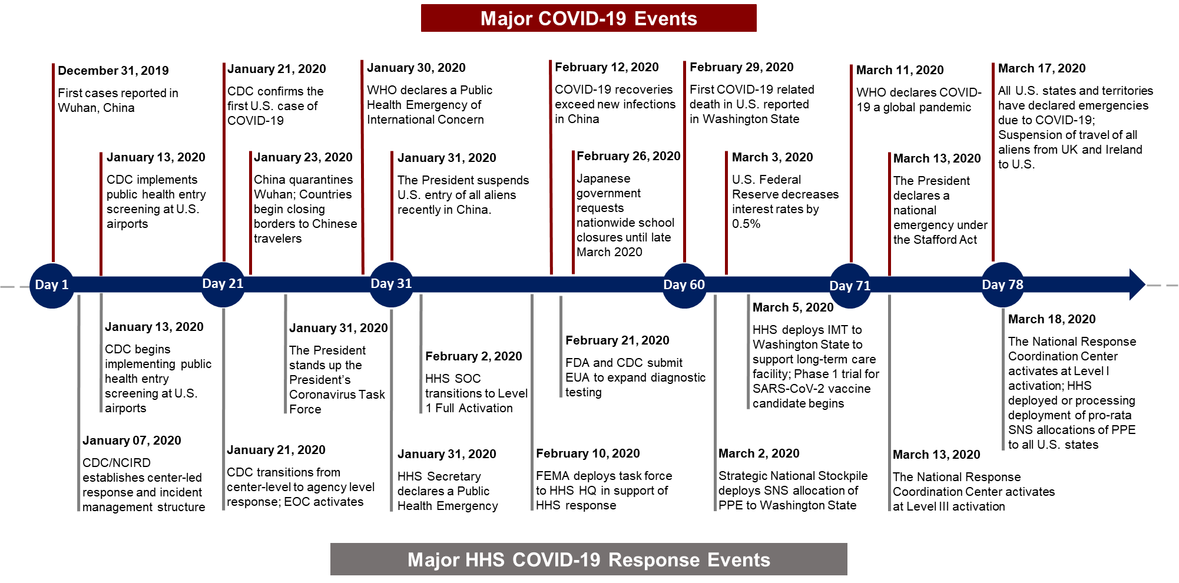

In Italy, the dramatic rise in COVID-19-related deaths provides an example of how the disease can quickly overwhelm a country’s fatality management systems at all levels. As of March 24, 2020, Italy had the second largest outbreak of COVID-19 outside of China, with 63,927 total confirmed cases, and the largest amount COVID-19-related deaths in the world, with 6,077 deaths.[4] Reports indicate that as COVID-19 deaths quickly mounted across the country, Italy’s fatality management systems at the local, provincial, and national levels could no longer manage the processing and burial of deceased individuals. Italy’s mortuary industry did not have sufficient masks or gloves to handle the deceased under normal operating standards, and hospital morgues were quickly inundated as patients died faster than the morgues could remove bodies for burial or cremation.[5] Additionally, national cancellations of mass gatherings and events, including funerals, created back-logs in churches and cemeteries with bodies in coffins awaiting burial in and outside churches.[6] Fear of infection has also led to delays in funeral companies retrieving those who died in their homes from COVID-19.[7]

To assist in preparing government, private sector, and nonprofit organizations in the United States to manage an increased number of fatalities caused by the COVID-19 pandemic, HHS/ASPR/Office of the Principal Deputy Assistant Secretary/Exercise, Evaluation, and After-Action Division has developed a tabletop exercise that examines topics such as coordination of fatality management operations; information collection and reporting; legal and regulatory considerations; supply chains and resource management; infection control; continuity of operations; mental and behavioral health services; and public messaging and risk communications.

## SitMan Purpose

The purpose of this SitMan is to guide participants representing government, private sector, and nonprofit organizations through a tabletop discussion focused on fatality management operations in the context of the COVID-19 pandemic. The SitMan provides a hypothetical scenario that depicts numbers of confirmed COVID-19 cases and deaths at the state, regional, and national levels over a period of 40 days and prompts participants to discuss how fatality management operations may evolve as the pandemic progresses.

This SitMan contains two sets of discussion questions—one set of questions for participants representing state or local organizations and another set of questions for participants representing federal departments and agencies or other national organizations. Exercise organizers should select the set of questions that is most appropriate for their chosen audience. Listed below are the steps that exercise organizers should take before, during, and after the exercise.

* **Invite attendees.** Exercise organizers may choose to invite participants representing any government, private sector, and nonprofit organizations that may be involved in managing fatalities caused by the COVID-19 pandemic.
* **Identify a facilitator.** The facilitator will be responsible for moderating and keeping participant discussions focused on the exercise objectives and ensuring relevant issues are explored as thoroughly as possible within time constraints.
* **Chose a date/time and send save-the-date emails.** When conducted as written, this exercise can last between 1.5 to 3 hours. Scheduling personnel involved during an ongoing pandemic response can be difficult, and should be done as soon as possible.
* **Provide this SitMan to participants.** Organizers should tailor this SitMan to meet the scope and scale desired and provide a copy to all exercise attendees as soon as possible prior to exercise conduct.
* **Designate note-takers/evaluators.** The role of note-takers/evaluators is to record the proceedings in their entirety.
* **Plan a hot wash.** To support ongoing planning efforts, exercise participants should consider using the final 15 – 30 minutes of the exercise to conduct a hot wash. During the hot wash, the facilitator should prompt key players to identify areas in need of the most improvement and discuss next steps.
* **Develop an after-action report.** Following exercise conduct, organizers should designate an individual or team to develop an after-action report that is based on the note-takers/evaluators’ input. Given the rapidly evolving nature of the COVID-19 pandemic, organizers should develop an after-action report within a condensed timeframe focused on identified action items.

Listed below are exercise objectives and outcomes. As previously mentioned, organizers may choose to remove or modify any of these objectives or outcomes as necessary to suit specific purposes.

## Exercise Objectives

* Discuss and determine how government, private sector, and nonprofit organizations will coordinate fatality management operations at the local, state, and national levels.
* Discuss and determine how response partners will record and track mortality information during the COVID-19 pandemic.
* Identify laws and regulations that may be altered or relaxed to expedite the process of managing large numbers of decedents.
* Discuss and determine what resources localities will request from states and what resources states will in turn request from the federal government to support fatality management operations, and discuss options for mitigating resource shortages.
* Discuss and determine what fatality management support, if any, state and local authorities could obtain from private companies.
* Discuss and determine what infection control practices response partners will employ when handling human remains and what restrictions state and local jurisdictions may place on visitations and funeral services to mitigate the spread of disease.
* Discuss and determine workforce protection measures government, private sector, and nonprofit organizations will implement to protect personnel involved in fatality management operations.
* Discuss and determine behavioral health guidance and support government and nonprofit organizations will provide to family members of the deceased and responders.
* Discuss and determine how governments and nonprofit organizations will develop and adapt public messaging regarding fatalities and fatality management operations as the number of deaths caused by COVID-19 increases.

## Exercise Outcomes

* Confirm the processes by which government, private sector, and nonprofit organizations will coordinate fatality management operations at the local, state, and national levels.
* Better understand the decisions that elected officials will need to make during a mass fatality event, and what information officials will need to make these decisions.
* Better understand the legal and regulatory landscape in which response partners will conduct fatality management operations.
* Identify key resources that state, local, tribal, and territorial (SLTT) partners will require to manage large numbers of fatalities during the COVID-19 pandemic and identify potential supply chains gaps or shortfalls.
* Better understand how to protect responders and the public from exposure to infectious human remains and identify the channels available for local, state, and federal public health officials to disseminate infection control guidance.
* Prepare SLTT and federal response partners to provide accessible public messaging and risk communications regarding fatalities and fatality operations throughout the COVID-19 response.
* Better prepare government, private sector, and nonprofit organizations at the local, state, and national levels to respond to mass fatalities resulting from the COVID-19 pandemic.

# Section 3: Exercise Scenario

## Scenario Overview

The hypothetical scenario described below is based on the current COVID-19 outbreak and was developed for discussion purposes only. **Please note that the scenario is not intended to serve as an official forecast.**

## Confirmed COVID-19 Cases

At the start of the exercise (STARTEX), there are 1,000 confirmed cases at the state level, 5,000 confirmed cases at the regional level, and 50,000 confirmed cases at the national level. By STARTEX + 40 days, there are approximately 274,000 cumulative confirmed cases at the state level, 1.3 million cumulative confirmed cases at the regional level, and 12.6 million cumulative confirmed cases at the national level, as depicted in **Figure 2** below.

Figure 2. U.S. Confirmed Cases at the State, Regional, and National Levels

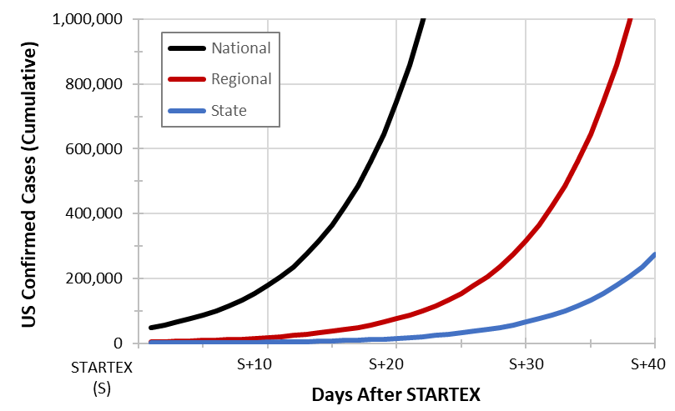

## Hospitalizations and Deaths

As time progresses, the number of deaths caused by COVID-19 begins to overwhelm state and local resources. With each day that passes, the daily number of new deaths increases, further straining resources. By STARTEX + 40 days, there are approximately 10,000 cumulative deaths in the state, with approximately 1,350 new deaths on Day 40 alone, as shown in **Figure 3** below.

Figure 3. New Daily Deaths at the State Level

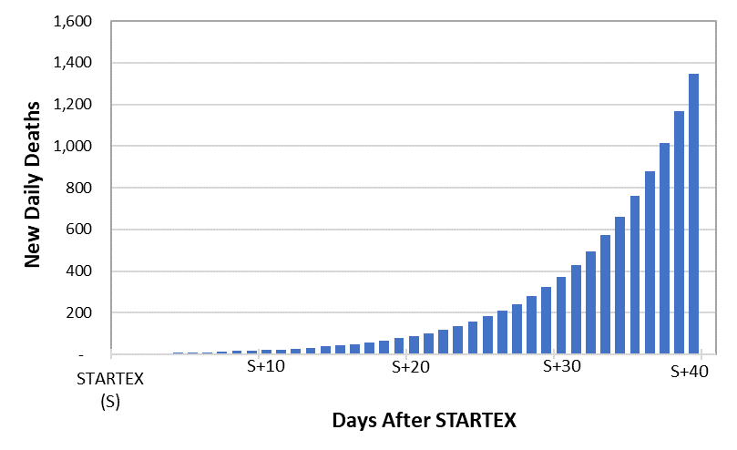

Regional resources also become overwhelmed by the number of deaths. By STARTEX + 40 days, there are approximately 49,000 cumulative deaths in the region, with approximately 6,500 new deaths on Day 40 alone, as shown in **Figure 4** below.

Figure 4. New Daily Deaths at the Regional Level

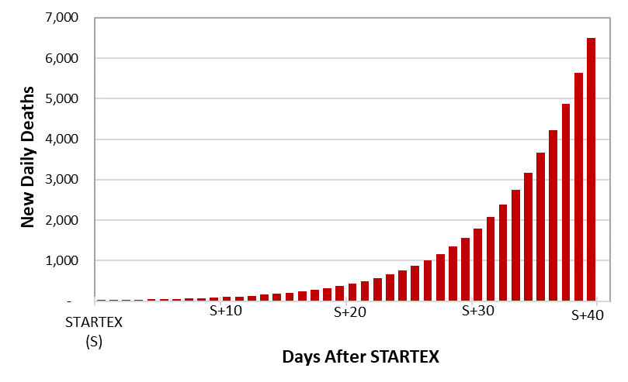

By STARTEX + 40 days, there are approximately 475,000 cumulative deaths in the United States, with approximately 62,300 new deaths on Day 40 alone, as shown in **Figure 5** below. SLTT partners across the country report that they are overwhelmed by the number of deaths.

Figure 5. New Daily Deaths at the National Level

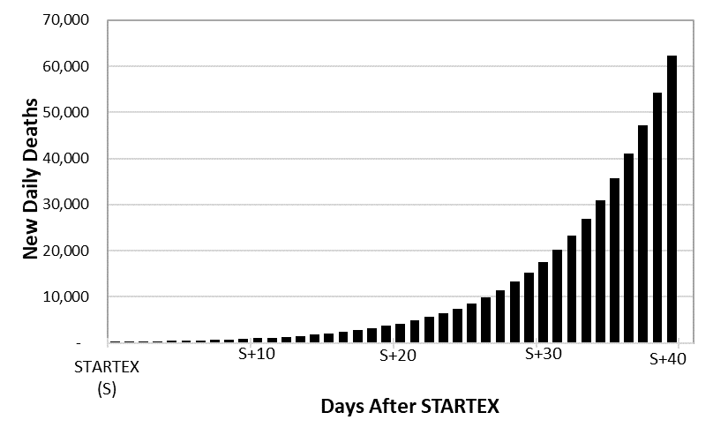

**Table 1** below shows the daily number of new deaths at the state, regional, and national levels, from STARTEX to STARTEX + 40 days.

Table 1. New Daily Deaths at the State, Regional, and National Levels

. New Daily Deaths at the State, Regional, and National Levels

**Table 2** below shows the daily number of new deaths for cities that make up small, medium, and large percentages of their state’s population, from STARTEX to STARTEX + 40 days. These calculations are based on the following assumptions:

* Small: Cities with approximately 5% of the state population
* Medium: Cities with approximately 10% of the state population
* Large: Cities with approximately 20% of the state population

Please note that the actual number of daily new deaths within a city will depend on several factors, including demographics, population density, and health care system capacity. For the purpose of this exercise, consider whether these factors may lead to higher or lower numbers of daily new deaths than the estimates shown in **Table 2** below. There is no requirement to adhere to the small, medium, or large designation based on population alone. Please select the estimates that allow participants to meet their desired exercise objectives.

Table 2. Daily New Deaths at the City Level

Daily New Deaths at the City Level

# Section 3: Discussion Questions

The following facilitator questions are intended to help guide the exercise participants’ discussion about **fatality management operations at the state and local levels, as well as at the national- or headquarters-level.** These questions are not meant to constitute a definitive list of issues, nor is there a requirement to address every question.

## State and Local-Level Discussion Questions

### Coordination of Fatality Management Operations

1. Within your jurisdiction, what organizations will be involved in managing fatalities resulting from the COVID-19 pandemic?
   1. Within each category listed below, who are the key partners, and what are their roles and responsibilities with respect to fatality management?
      1. Funeral directors and crematoriums
      2. Coroners and medical examiners
      3. Emergency management agencies
      4. Public health agencies
      5. Emergency medical services
      6. Hospitals and healthcare facilities
      7. Vital records registrars
      8. Law enforcement agencies
      9. Elected officials
      10. Faith and community-based organizations
   2. How will these partners coordinate fatality management activities during the COVID-19 response?
      1. Is there a lead agency responsible for coordinating fatality activities within your jurisdiction? If so, which agency is designated as the lead, and what responsibilities are associated with this designation?
      2. How will response partners establish and maintain a common operating picture with respect to fatality management?
2. Does your jurisdictions have a mass fatality management plan for pandemics or infectious diseases? If so, what are the triggers to implement this plan? Have response partners received training on the plan?
   1. Does your jurisdiction have a fatality management plan for other, more commonly occurring disasters that can be adapted for mass fatalities during COVID-19?
3. As the COVID-19 pandemic progresses, at what point will your jurisdiction’s fatality management resources become overwhelmed? What metrics will you use to determine when existing resources will no longer be sufficient to meet the needs of the response (e.g., human remains storage capacity, funeral home storage capacity, elapsed time between death notification and transport)?
4. What key decisions will elected officials need to make with respect to mass fatality management in your jurisdiction?
   1. What information will elected officials need to inform these decisions, and who is responsible for providing this information?
   2. At what point during the response will elected officials need to make these decisions, and who is responsible for implementing the decisions?

### Information Collection and Reporting

1. How does your jurisdiction record and track fatalities?
   1. Who is responsible for managing the collection of the following information?
      1. Reported deaths
      2. Refrigerated storage capacity
      3. Funeral home capacity
      4. Whereabouts and status of the deceased
   2. What additional information is needed to support operational decision-making?
   3. Is there a centralized system in place to capture this information? Who is responsible for reporting this information, and what reporting channels will they use? Who has access to view the information?
   4. In the event of a mass fatality incident, will the frequency at which information is updated change?
2. What information sharing challenges, if any, do you anticipate during a mass fatality event?

### Laws and Regulations

1. During a pandemic event, several variables have the potential to slow down the process of managing decedents. What laws and regulations may be altered or relaxed to expedite activities in the following areas?
   1. **Signing of death certificates.** Physicians may not be available to sign death certificates, particularly when their patient dies at home, because they will be focused on providing medical care to the living.
   2. **Identification of decedents.** A decedent’s family members may also be ill and therefore unavailable to identify the body. Normal Disaster Victim Identification (DVI) Committee practices may need to be altered to accommodate a protracted response by family members.
   3. **Unattended deaths.** Those who die without family and friends present multiple challenges, including restrictions on entering the residence without law enforcement, difficulty establishing decedent identity or locating next of kin, management of the decedent’s pets, and management of the decedent’s estate.
   4. **Cremation permitting.** Cremation permitting typically requires an examination by a state authorized medical professional to ensure that there is no crime, accident, or public health issue that may be covered up by a cremation. In the event of a pandemic, a high number of requests may cause a slowdown. Additionally, some jurisdictions may choose to direct cremation of those who die with COVID-19. Though cremated remains may present some hazard due to the infection, they are easier to handle than unembalmed or embalmed bodies.
   5. **Cremation capacity.** A large influx of voluntary cremation requests may exceed existing capacity restrictions. Additionally, a lack of fuel or lack of staff may limit cremation capacity.
   6. **Embalming process.** Because embalming is a labor-, equipment-, and supply-intensive process, some jurisdictions may chose not to embalm remains during a pandemic.
   7. **Disposition of unidentified or unclaimed remains.** If storage facilities reach capacity and additional cold storage units are unavailable, it may be necessary to establish contracts with public and/or private cemeteries or other property holders for the disposition of unidentified or unclaimed remains.
2. In your state, what governing authority do local governments follow? Specifically, does your state follow (1) Home Rule, which gives local governments governing authority to make a wide range of legislative decisions that have not been addressed by the state; (2) Dillon’s Rule, which creates a framework where local governments can only legislate what the state government has decreed); or (3) a limited application of either Home Rule or Dillon’s Rule?
   1. In what ways does the type of governing authority help or hinder your jurisdiction’s ability to safely and efficiently manage a mass fatality incident?
3. What additional legal or regulatory challenges may the COVID-19 pandemic present with respect to fatality management? What steps may be taken to mitigate these challenges?

### Supply Chains and Resource Management

1. What key resources does your jurisdiction require to manage fatalities caused by COVID-19 (e.g., body bags, refrigerated trucks, personal protective equipment [PPE])?
   1. How will your jurisdiction track the availability of these resources?
   2. As the number of fatalities in your jurisdiction increases, what resource shortages do you anticipate within the funeral industry and across the full range of agencies and organizations that support fatality management operations? What steps can your jurisdiction take to mitigate or address these shortages? Do you have plans in place to:
      1. Implement crisis/alternate strategies to optimize the use of PPE?
      2. Procure additional vehicles for transportation of the deceased?
   3. What resource shortfalls and gaps will localities report to states, and what resource shortfalls or gaps will states report to the federal government?
      1. Through what channels will resource requests be made?
      2. At the state level, how will requests for scarce resources be adjudicated? What is the process for prioritizing and allocating scarce resources?
      3. With respect to PPE specifically, does your jurisdiction have a prioritization schema for distribution of PPE supplies to the health and medical sector? If so, where does the death care industry fall within this schema?
   4. What fatality management support, if any, could your jurisdiction obtain from private companies (e.g., Kenyon International Emergency Services, Inc.; SparrowHawk Global, LLC)?
2. In the event that the number of decedents overwhelms the capacity of existing human remains storage facilities, does your jurisdiction have a plan to establish temporary facilities to store bodies prior to transfer to funeral homes?
   1. What factors will you consider when identifying facilities to serve as temporary storage facilities? (i.e., cold storage capabilities, ventilation, floor drainage, communication capabilities)?
   2. Who is responsible for deciding when temporary storage facilities are needed, and who will assist in securing the necessary resources to establish temporary storage facilities?

### Infection Control

1. What biosafety and infection control practices will state and local public health officials recommend to medical examiners, coroners, pathologists, and other workers involved in the postmortem care of deceased persons confirmed with or under investigation for COVID-19? Specifically, what infection control practices will be recommended for the following activities:
   1. Collection of postmortem specimens
   2. Preparation of specimens for shipment
   3. Cleaning and waste disposal following an autopsy
   4. Transportation of human remains
2. How will personnel be monitored to ensure compliance with infection control protocols? What guidelines will be implemented to determine whether personnel should be directed to stay home (e.g., monitoring of daily body temperatures, screening for COVID-19 symptoms)?
3. What infection control practices will responders employ when retrieving decedents who have died from COVID-19 in their homes? What challenges, if any, will responders face when retrieving decedents from their homes?
4. What steps will your jurisdiction take to minimize the risk of disease transmission at visitations and funerals?
   1. Who is responsible for making decisions regarding visitation and funeral attendance restrictions?
   2. How will public officials coordinate with faith and community-based organizations to ensure that visitations and funerals are conducted safely and in accordance with applicable state and local restrictions?

### Continuity of Operations

1. Across the range of government, private sector, and nonprofit organizations involved in fatality management within your jurisdiction, what workforce protection measures are currently in place (e.g., travel and meeting restrictions, remote work)? What additional measures will become necessary as the number of fatalities increases?
   1. What are the triggers for implementing additional workforce protection measures, and who is involved in making these decisions?
2. At what threshold will staff absenteeism begin to compromise the ability of response partners to conduct fatality management operations?
   1. How will response partners identify and onboard surge staff to fill essential roles?
   2. If staffing shortages cannot be overcome, which functions would be prioritized? Who is authorized to redirect staff or resources to those priority functions, and what information is needed to make that decision?

### Mental and Behavioral Health Services

1. Does your jurisdiction have the capability to establish a virtual Family Assistance Center to collect antemortem information from family and friends of the deceased and provide bereavement support, psychological first aid, and other mental health services during the COVID-19 pandemic? If so:
   1. What are the triggers for standing up the virtual FAC?
   2. Who is responsible for managing the FAC, and what organizations will be involved in providing support services?
   3. What specific support services will the FAC provide?
2. What mental and behavioral health support will be available for families and friends of the deceased and responders during the COVID-19 pandemic? Specifically, what types of support may following groups provide:
   1. Mental and behavioral health professionals
   2. Spiritual care providers
   3. Hospices
   4. Translators
   5. Embassy and Consulate representatives when international populations are involved
3. Within your jurisdiction, what prominent cultural, religious, and family practices may require additional consideration or accommodation when managing fatalities?

### Public Messaging and Risk Communication

1. How will state and local public health officials develop and disseminate public messaging and risk communications regarding fatalities and fatality management during the COVID-19 pandemic?
   1. What key information will officials share with the public as the pandemic progresses?
   2. How will public messaging address fear and stigma associated with deaths caused by COVID-19?
2. Who will serve as your jurisdiction’s primary spokesperson to provide information regarding fatalities and impacts of the COVID-19 pandemic on funeral procedures to the public?
3. What processes are in place to ensure public messaging and risk communications regarding COVID-19 fatalities are accessible to all members of the community, including, but not limited to, the homeless, people living in isolated communities, non-English speakers, children, people in institutional settings, and those with physical, cognitive, or behavioral disabilities?

## National-Level Discussion Questions

### Coordination of Fatality Management Operations

1. Over the course of the COVID-19 pandemic, what federal and national nonprofit organizations will provide fatality management support to SLTT partners?
   1. What types of support will these organizations provide in the following areas?
      1. Victim identification
      2. Remains transport
      3. Mortuary affairs processing
   2. What additional fatality management support may these organizations provide?
2. As SLTT jurisdictions across the U.S. begin to experience a higher number of fatalities than they can handle, how will federal partners and national nonprofit organizations scale up their level of support?
   1. What are the triggers and thresholds for enhanced mobilization of federal assets to support SLTT fatality management operations?
   2. Within the federal government, who is responsible for making decisions regarding the activation and deployment of fatality management assets?
   3. How are federal partners coordinating with national voluntary organizations active in disasters (VOADs) to support SLTT fatality management operations?

### Situational Assessment and Information Management

1. How will federal response partners gather and report on fatality management information from SLTT partners?
   1. Through what channels will SLTT, private sector, and nonprofit partners report this information?
   2. Who is responsible for compiling this information, and how will this information be incorporated into federal reporting products (e.g., Situation Reports, Senior Leader Briefs)?
   3. What information will federal partners share with private sector and nonprofit partners, and through what channels will they share this information?

### Laws and Regulations

1. How will differences in local and state laws and regulations related to fatality management impact the ability of the federal government and national VOADs to provide support?
2. Are there laws or regulations at the federal level that could be altered or relaxed to allow for more streamlined fatality management operations?

### Supply Chains and Resource Management

1. What resource shortfalls and gaps do you anticipate SLTT partners will report to federal government or national VOADs, and what resources will the federal government and national VOADs deploy to support SLTT fatality management operations (e.g., body bags, refrigerated trucks, PPE)?
   1. Which of these resources are stockpiled and available for deployment to SLTT partners? What quantities of these resources are available, and what is the process for prioritization and allocation?
   2. How will federal partners coordinate with private sector and nonprofit organizations to fill remaining resource gaps?
2. Will HHS deploy disaster mortuary operational response teams (DMORTs) to support SLTT partners? Under what circumstances would DMORTs deploy, and under what circumstances would SLTT requests for DMORT assistance be denied?
3. If SLTT partners lack sufficient sites for temporary body storage, will the federal government provide access to federal facilities and lands? Who is responsible for making these decisions, and what information is required to inform these decisions?

### Infection Control

1. What guidance will federal partners and national nonprofit organizations provide to SLTT partners related to the following areas?
   1. Infectious disease mortuary care
   2. Temporary body storage and burials
   3. Retrieval of deceased in private residences
   4. Infection control for the funeral homes and crematoriums
   5. Contingency and crisis/alternative strategies for use of PPE
2. What infection control training will federal personnel receive before deploying to support SLTT fatality management operations?

### Mental and Behavioral Health Services

1. What guidance and resources will federal and national nonprofit organizations provide to SLTT partners to assist them in offering non-intrusive, culturally sensitive mental and behavioral health support services to family members of the deceased, recovering COVID-19 patients, and responders?
   1. What platforms and channels will federal and national nonprofit organizations use to share mental and behavioral health guidance?
   2. Will federal and national nonprofit organizations deploy personnel or teams to provide mental and behavioral health services? If so, what are the triggers for deploying these teams?

### Public Messaging and Risk Communication

1. Who will serve as the primary federal spokesperson for communication of fatality management guidance to state or local governments?
2. How will messages be coordinated across federal departments and agencies involved in supporting fatality management operations?
   1. As the number of deaths continues to grow and begins to overwhelm SLTT resources, how will federal partners adapt their public messaging?
3. How will federal partners coordinate messaging with national nonprofit organizations that engage with death care professionals, such as the National Funeral Directors Association?
4. What processes are in place to ensure public messaging and risk communications regarding COVID-19 fatalities are accessible to all members of the community, including, but not limited to, the homeless, people living in isolated communities, non-English speakers, children, people in institutional settings, and those with physical, cognitive, or behavioral disabilities?

# Appendix A: Acronyms and Abbreviations

| Acronym or Abbreviation | Meaning |
| --- | --- |
| ASPR | Office of the Assistant Secretary for Preparedness and Response |
| COVID-19 | Coronavirus Disease 2019 |
| DMORT | Disaster Mortuary Operational Response Teams |
| FAC | Family Assistance Center |
| HHS | U.S. Department of Health and Human Services |
| PPE | Personal Protective Equipment |
| SitMan | Situation Manual |
| SLTT | State, Local, Tribal, and Territorial |
| STARTEX | Start of Exercise |
| VOAD | Voluntary Organization Active in Disasters |

1. The **disease** is named COVID-19, while the **virus** is named SARS-CoV-2.
2. Severe Outcomes Among Patients with Coronavirus Disease 2019 (COVID-19) — United States, February 12–March 16, 2020. MMWR Morb Mortal Wkly Rep. ePub: 18 March 2020. DOI: http://dx.doi.org/10.15585/mmwr.mm6912e2
3. Reported by the New York Times on March 13 based on unreleased CDC scenarios that estimated U.S. illnesses, hospitalizations, and deaths resulting from the COVID-19 pandemic across four possible scenarios. Sheri Fink, “Worst-Case Estimates for U.S. Coronavirus Deaths”, *New York Times*, March 13, 2020, accessed March 18, 2020, https://www.nytimes.com/2020/03/13/us/coronavirus-deaths-estimate.html.
4. As reported by the Johns Hopkins Coronavirus Resource Center: https://coronavirus.jhu.edu/map.html
5. Emma Bubola and Jason Horowitz, “Italy’s Coronavirus Victims Face Death Alone, With Funerals Postponed”, *The New York Times*, March 16, 2020, accessed March 19, 2020, https://www.nytimes.com/2020/03/16/world/europe/italy-coronavirus-funerals.html.
6. Ibid.
7. Antonia Noori Farzan, “‘Italy has abandoned us’: People are being trapped at home with their loved ones’ bodies amid coronavirus lockdown”, *The Washington Post*, March 12, 2020, accessed March 19, 2020, https://www.washingtonpost.com/nation/2020/03/12/coronavirus-bodies-italy-quarantine/.