7th Annual Wine Walkabout
Thursday, November 14, 2019
5:30 PM – 7:30 PM

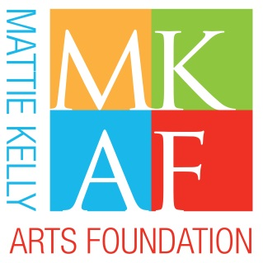

2nd

MKAF Wine Pull Donation Form

Please support MKAF by donating one or multiple bottles of wine to the MKAF Wine Pull at the Ruth’s Chris Wine Walkabout. The Wine Pull features 100 bottles of wine in a grab-bag style fundraiser wherein participants purchase a numbered cork to win a bottle of wine that may range in retail value from $50 to $200 or more. Cash donations are also welcome.

Donor Name:

Business (if applicable):

Address:

City: State: Zip Code:

Daytime Phone: Email:

We ask that donated bottles have a minimum retail value of $50
Donation deadline – October 28, 2019

Wine Name Type & Year Value

I cannot donate a bottle of wine but wish to contribute $

Please email form to info@mattiekellyartsfoundation.org
If you have any questions please call 850-650-2226

BUILDING THE FOUNDATION OF ARTS AND CULTURE IN OUR COMMUNITY!

Please submit completed form to info@mattiekellyartsfoundation.org or return to MKAF committee contact. To schedule a delivery to MKAF office, 4323 Commons Drive West, Destin, FL 32541, please call 850-650-2226. All proceeds benefit MKAF’s cultural programs and community outreach initiatives.

GIFTS TO THE MATTIE KELLY ARTS FOUNDATION MAY BE CHARACTERIZED AS CHARITABLE CONTRIBUTIONS PURSUANT TO SECTION 162 OF THE IRS CODE. A COPY OF THE FOUNDATION’S REGISTRATION AND FINANCIAL INFORMATION MAY BE OBTAINED FROM THE DIVISION OF CONSUMER AFFAIRS BY CALLING TOLL-FREE (800-435-7352) WITHIN THE STATE. REGISTRATION DOES NOT IMPLY ENDORSEMENT, APPROVAL OR RECOMMENDATION BY THE STATE.

