2019 LeadingAge California Wage Survey
Instructions & Position Descriptions

INTRODUCTION

The 2019 LeadingAge California Wage Survey is being conducted in order to collect important data that will be used in two ways: 1) to offer participating communities’ information about practices across the state that will inform decisions related to management and employment, and 2) in advocacy efforts and as a tool to educate policymakers. Participation in the survey is voluntary and responses will be kept confidential.

INSTRUCTIONS

The survey can be accessed on-line via a link provided in invitations distributed through several mediums. Additions and changes will be saved as you progress. You can use the “Back” button at the bottom of any page to go backwards in the survey and review answers previously entered.

Important Notes:
- If you need to pause and step away during the completion of the survey, you can do so, and then click on the survey link again from the same computer to take you back to the last point of completion. BUT this return feature only works if cookies are turned on and not deleted on your computer in between sessions. We highly recommend that you complete the survey in one session, if possible, to avoid having to re-do any work should your partially completed survey not be accessible.
- Your submission will only be marked as “complete” if you click the “Continue” button on the last page of data entry and see the “Thank You” page.
- Each individual email address can only be used for one submission. If you need to have one person complete multiple surveys for multiple locations, please forward the email to the appropriate person.

The survey contains three main sections:
- Information about your community
- Information about FTEs and wages for each position in five groups
  - Facility Management & Administration
  - General Administration
  - Nursing/Health Services
  - Food Services
  - Housekeeping & Maintenance
- Information about employment benefits

For consistency, we request that the survey is completed at the location or community level. If you have multiple locations, please complete one survey for each. If you have multiple services in one location, please complete one survey representative of all the services.

Most of the fields in the first section, collecting information about your community, are required. After that, most fields are optional. Please answer only items that apply to your organization.

You can find additional notes with field definitions and answers to commonly asked questions on the next page of this document. Screen shots of the data entry fields can be found on pages 4 through 8; we recommend that you review these and collect the data ahead of starting the on-line survey process. Finally, position descriptions can be found on pages 9 through 16, organized to parallel the survey.

If you have any questions or any feedback, please email tmcostello@nrchealth.com and include “CA Wage Survey” in the subject line to make sure that your question is appropriately triaged.

NOTES

FTEs – When FTEs are requested, please enter the number of “full-time (40 hours per week) equivalent” staff (for example, if two part-time employees work twenty hours per week each, they would count as one FTE).

Positions – The list of positions included in the survey may not exactly match the positions in your organization. Please use the “Positions Descriptions” section to best match your positions to those in the survey, and leave blank any positions in the survey that don’t match any of the positions at your community.

Annual Salary vs. Hourly Wage – Positions are categorized as salary or hourly. For salary positions, please provide the annual salary. For hourly positions, please provide the hourly pay rate. If a position is categorized differently on the survey than it is in your organization (for example, you pay your office manager an annual salary instead of an hourly wage, or your Marketing Representative an hourly wage instead of an annual salary), please use 2,080 hours to convert the annual salary to hourly wage or vice versa.

Minimum, Midpoint, and Maximum

Minimum – Enter the minimum amount being earned by an employee in this position today.

Midpoint – Enter the median salary you are currently paying for this position (not the average). If you have only one person in the position, enter this value.

Maximum – Enter the minimum amount being earned by an employee in this position today.

First Page of the Survey, requesting information about your organization:
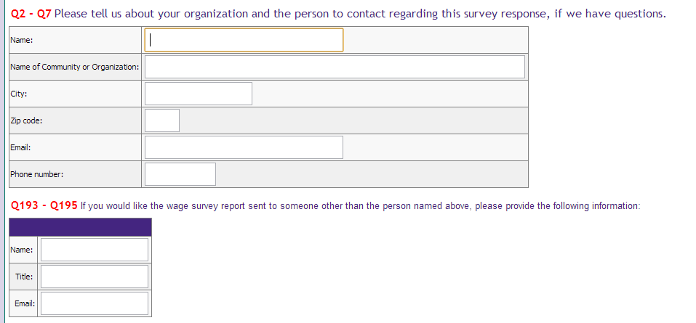
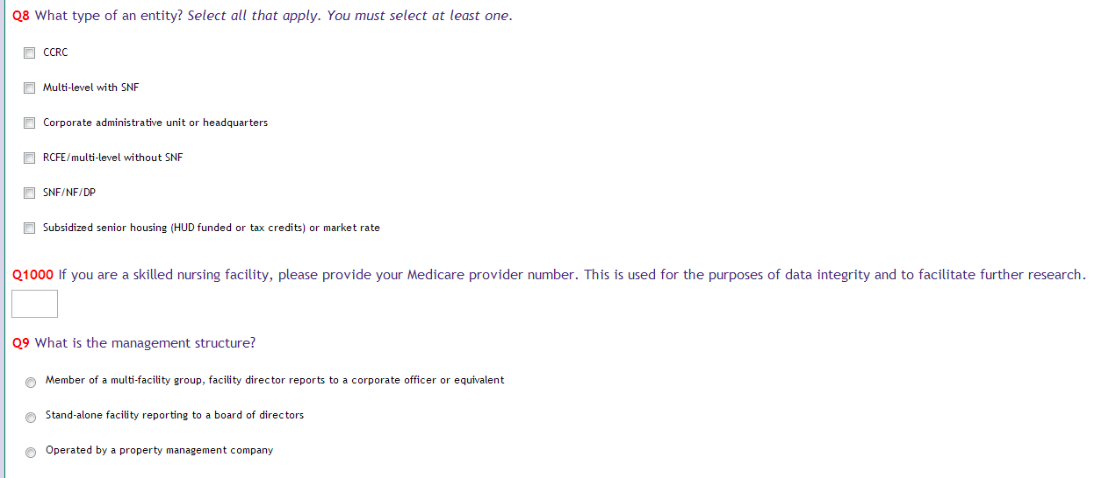
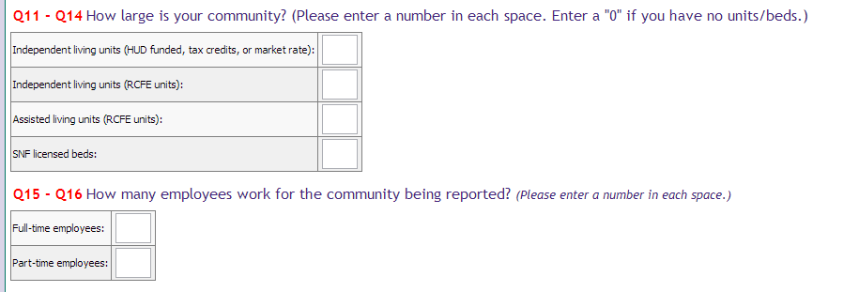

COMMUNITY MANAGEMENT & ADMINISTRATION Positions
The descriptions in this job family match positions whose incumbents are directly responsible for community management and administration. See the “General Administration” job family for professional, administrative, secretarial, and clerical positions that may match either headquarters staff or community staff.

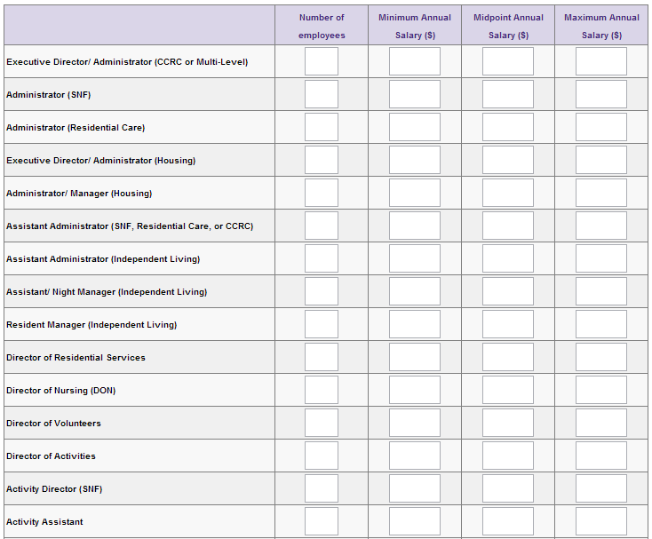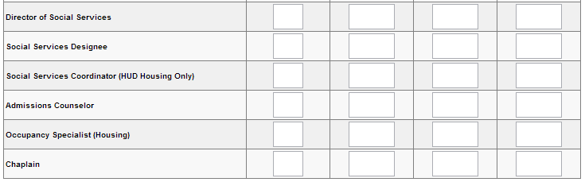

GENERAL ADMINISTRATION Positions
Descriptions in this job family are intended to match positions on the staff of a multiple-community headquarters or corporate management unit. Larger standalone communities may also have these positions on staff.
Annual Salary Positions
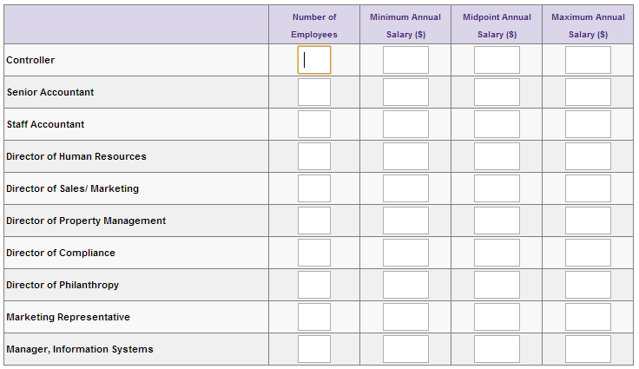
Hourly Wage Positions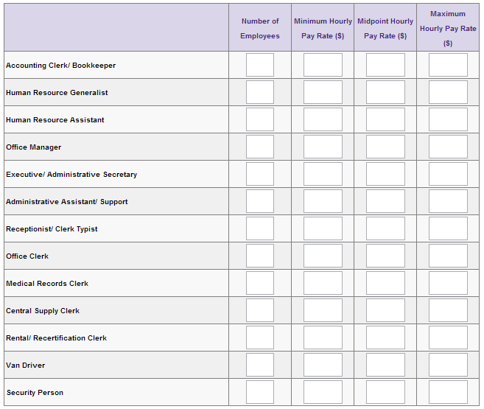
NURSING/HEALTH SERVICES Positions
The descriptions in this job family match positions associated with resident care.

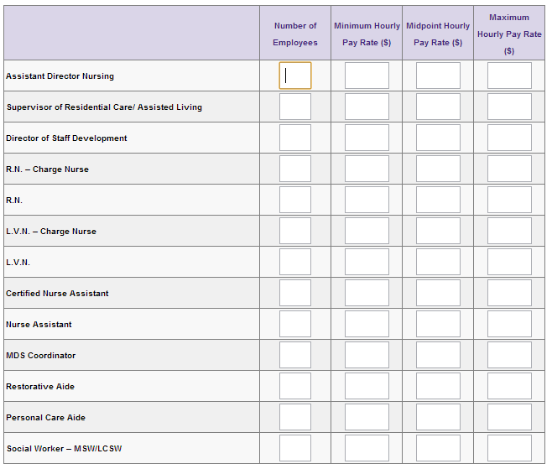

FOOD SERVICES
The descriptions in this job family match positions associated with food services.
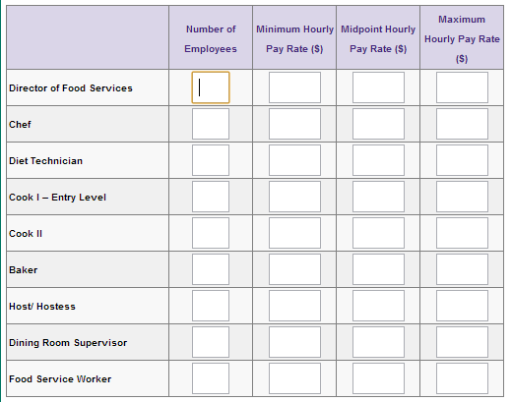
HOUSEKEEPING AND MAINTENANCE Positions
The descriptions in this job family match positions associated with housekeeping and maintenance.
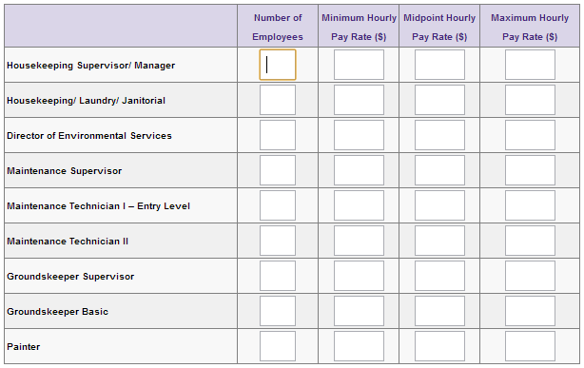
Position Descriptions

COMMUNITY MANAGEMENT & ADMINISTRATION
The descriptions in this job family match positions whose incumbents are directly responsible for facility or community management and administration. See the General Administration job family for professional, administrative, secretarial, and clerical positions that may match either headquarters staff or facility staff.

CEO or EXECUTIVE DIRECTOR/ADMINISTRATOR (CCRC OR MULTI-LEVEL)
Responsible for overall management of Continuing Care Retirement Community. Implements policies and procedures established by a governing body or entity, ensuring compliance with governmental regulations. Coordinates departmental functions and organizes facility programs within established budgets. Provides leadership in long-range strategic planning. Represents the organization in the community and ensures that socially responsible programs are implemented and viable.

ADMINISTRATOR (SKILLED NURSING FACILITY)
Responsible for overall management of skilled nursing facility. Enforces facility policies and ensures compliance with state licensing regulations including OBRA. Coordinates departmental functions and organizes facility programs within established budgets. Implements policies and procedures established by a governing body or entity.

ADMINISTRATOR (RESIDENTIAL CARE)
Responsible for overall management of residential care facility. Enforces organization policies and ensures compliance with governmental regulations. Coordinates departmental functions and organizes facility programs within established budgets. Implements policies and procedures established by a governing body or entity.

EXECUTIVE DIRECTOR/ADMINISTRATOR (HOUSING)
Responsible for overall management of housing community. Implements policies and procedures established by a governing body or entity, ensuring compliance with governmental regulations.
Coordinates departmental functions and organizes facility programs within established budgets.
Provides leadership in long-range strategic planning. Reports to board of directors.

ADMINISTRATOR/MANAGER (HOUSING)
Responsible for overall management of facility. Enforces organization policies, ensures compliance with regulatory agencies, and is responsible for fiscal control. Organizes facility programs to benefit residents and is responsible for volunteer activities. Reports to corporate staff.

ASSISTANT ADMINISTRATOR (SKILLED NURSING, RESIDENTIAL CARE, OR CCRC)
Assists Facility Administrator in managing operations and maintaining positive staff relationships. In larger facilities, may have responsibilities over marketing or other ancillary departments. Participates with the Administrator in budget planning and expense control.

ASSISTANT ADMINISTRATOR (INDEPENDENT LIVING)
Assists Facility Administrator in managing operations. May be responsible for interviewing, certification, and recertification of residents. May also serve as Director of Resident Programs and Activities.

ASISTANT/NIGHT MANAGER (INDEPENDENT LIVING)
Responds to and handles emergencies at night and on weekends. Checks buildings for security on an established schedule during the night.

RESIDENT MANAGER (INDEPENDENT LIVING)
Lives on-site and is responsible for overall management operations. Responsible for handling emergencies on nights and weekends. Works under the direct supervision of the management agent.

DIRECTOR OF RESIDENTIAL SERVICES
Plans, organizes and directs social, educational, and recreational programs to meet resident needs, interests and abilities. Reports to Facility Administrator.

DIRECTOR OF NURSING (DON)
Plans, supervises and coordinates all resident care and healthcare nursing. Supervises nursing service personnel. Responsible to the Facility Administrator for ensuring compliance with applicable regulations.
DIRECTOR OF ACTIVITIES
Plans, organizes and directs social, educational, and recreational programs to meet resident needs, interests and abilities. Reports to Facility Administrator.

ACTIVITY DIRECTOR (SNF)
Responsible for the development and implementation of an activities program that meets the needs and interests of skilled nursing facility residents, in accordance with Title 22, for both ambulatory and nonambulatory residents. Maintains records of activities provided and resident participation. Participates in resident care planning meetings. Conducts in-service education programs for skilled nursing staff. Develops and maintain contact with community agencies and organizations.

ACTIVITY ASSISTANT
Assists Activity Director in developing and conducting organization and community activities for patients/residents. Coordinates, with organization staff, functions such as discussion groups, exercise groups, arts, crafts, movies and games.

DIRECTOR OF SOCIAL SERVICES
Refers and assists residents and families to secure community-based aid and services, such as transportation, not offered by the organization. May work with community programs to bring services on site.

SOCIAL SERVICES DESIGNEE
Counsels and aids individuals and families who require assistance. Interviews new residents to assess their psychosocial needs. Obtains information such as medical, psychological, and social factors contributing to the resident’s situation, and evaluates resident’s capacities. Counsels residents individually, or with family, regarding assessments plans. Aids residents to improve social functioning. May refer resident to community health resources and other organizations.

SOCIAL SERVICES COORDINATOR (HUD HOUSING ONLY)
Identifies frail resident and assists in arranging for services by community agencies. Works with hospitals and home health agencies as well as social service workers from government service agencies. Provides information and referrals to residents about available social services and benefits. MSW is not required.

ADMISSIONS COUNSELOR
Assists residents with orientation to organization operation and rules. Assists potential residents with applications and in accessing organization services.

OCCUPANCY SPECIALIST (HOUSING)
Responsible for determining housing assistance eligibility, occupancy standards, income calculations and allowances. Responsible for applicant screening and selection, fair housing compliance, certification and re-certification of residents. Has a comprehensive understanding of project requirements and programs regulations for housing and rental assistance.

CHAPLAIN
Provides religious counseling and guidance to residents, family members and employees. Performs church rites, or arranges for appropriate religious leader to do so, as requested by patient, resident, or family. May act as liaison between organization staff, family and friends of residents during period of crisis.
GENERAL ADMINISTRATION
Descriptions in this job family are intended to match position on the staff of a multiple-facility headquarters or corporate management unit. Larger stand-alone facilities may also have these positions on staff.

CONTROLLER
Manages corporate or facility accounting activities. Oversees preparation of annual budgets, financial reports and tax returns. Assists department heads with systematic collection of data for financial reporting. Monitors expenses for compliance with budgetary goals. Recommends changes that enhance fiscal accountability. Supervises professional accounting staff.

SENIOR ACCOUNTANT
Performs general accounting activities, including the timely and accurate preparation of financial statements and reports. Facilitates the flow of information between headquarters and facility
accounting staffs. Visits facilities to resolve accounting issues and determine compliance with accounting policies.

STAFF ACCOUNTANT
Prepares and enters standard and adjusting journal entries. Prepares monthly operating reports and allocations. May maintain fixed assets ledger and prepaid accounts. Distributes month-end reports. Maintains assigned balance sheet accounts.

DIRECTOR OF HUMAN RESOURCES
Provides leadership in all aspects of human resource development and management. Provides human resource consultation to managers and to facility administrators and executive directors. Reports to chief executive officer.

DIRECTOR OF SALES/MARKETING
Manages the marketing of services and all business development activities. Ensures that sales personnel have adequate guidance and support to assist them in converting prospects into residents. Develops collateral materials and advertising campaigns to promote the organization’s facilities and services.

DIRECTOR OF PROPERTY MANAGEMENT
This position ensures that the operations of the properties in assigned area of oversight are in compliance with the standards and expectations of the organization. Responsible for monitoring and directing all management-related activities with site-level personnel and other related departments to ensure that the Essential Functions are met on a regular and consistent basis. Responsibilities may include daily operations of site staff; recruiting, hiring and development of staff; asset management; and regulatory relationship management.

DIRECTOR OF COMPLIANCE
An Affordable Housing Compliance Director is responsible for reporting and monitoring the compliance requirements for the community or communities. Works directly with the onsite staff to ensure the community meets their compliance requirements. This position works with the audit processes and systems to ensure on-going adherence and accountability to the Affordable Housing policies and procedures, including compliance with HUD regulations.

DIRECTOR OF PHILANTRHOPY
This management position oversees all philanthropy staff. Works with senior team to develop and implement annual fundraising goals and initiatives. Develops and implements strategies to identify, cultivate, solicit, and provide stewardship for community residents, family members and friends, staff, community members, corporations and foundations. Oversees all aspects of collateral materials, fundraising events, volunteer activities involving fundraising, planned giving, donor recognition, and all other related philanthropy functions.

MARKETING REPRESENTATIVE
Functions as an assistant to the Director of Marketing. Primary responsibilities are the development of qualified leads and the fulfillment of the organization marketing plan. Manages application and movein documentation. May have alternative work-week to ensure weekend availability to walk-in prospects.

MANAGER, INFORMATION SYSTEMS
Manages the organization’s information systems, including the development and implementation of new computer-based applications. Works with users of the organization’s information systems to ensure maximum usefulness of information and procedures. Monitors vendors and outside contractors to ensure that performance satisfies contractual agreements.

ACCOUNTING CLERK/BOOKKEEPER
Maintains generals and subsidiary ledgers. Issues checks, processes payroll, makes bank deposits and prepares statements.

HUMAN RESOURCE GENERALIST
Responsible for human resource function in a single facility. Alternatively, may be responsible for two or more human resource generalist activities in a larger organizational unit. Responsibilities typically include recruiting, compensation, benefits, equal opportunity and affirmative action, labor relations training, and safety.

HUMAN RESOURCE ASSISTANT
Answers routine questions related to employee benefits and established personnel policies and practices. Performs one or more HR generalist activities such as performance appraisal administration, salary administration, pre-screening applicants for employments, and compiling statistics for statutory and internal reports. Performs clerical duties common to personnel administration.

OFFICE MANAGER
Completes administrative assignments for facility/organization management. Develops and implements procedures. Supervises and trains office clerical employees. Typically reports to a facility administrator.

EXECUTIVE/ADMINISTRATIVE SECRETARY
Provides secretarial and administrative support to facility administrator, management staff, corporate office directors, or executive staff. May facilitate inter-organization communication at corporate level. Acts with varying degrees of independence and judgment. Coordinates meetings involving administrative staff and executives. This is the highest level non-exempt secretarial position in the organization.

ADMINISTRATIVE ASSISTANT/SUPPORT
Provides a variety of administrative support including word processing, spreadsheets, presentation graphics; operates office equipment; maintains files and records; orders office supplies; maintains schedules and calendars. This is an intermediate level position, generally requiring at least one year of qualifying experience.

RECEPTIONIST/CLERK TYPIST
Operates telephone system. Receives visitors, type’s letters and correspondence.

OFFICE CLERK
Performs various routine clerical duties. Prepares records and reports and may do light bookkeeping. Responds to correspondence.

MEDICAL RECORDS CLERK
Assembles patient medical records and reviews for completeness. May compile data from medical records for statistical reports. Reviews records for required reports and documents.

CENTRAL SUPPLY CLERK
Maintains inventory of supplies and materials. May distribute nursing and medical supplies and materials to departments and staff. Orders supplies and equipment. May sterilize instruments and disinfect equipment.

RENTAL/RECERTIFICATION CLERK
Processes income received, including rents. Prepares bank deposits, balance due letters and EOM accounting reports. Certifies/re-certifies tenants for HUD rental assistance programs. Prepares Section 8 vouchers. May participate in tenant selection process.

VAN DRIVER
Operates organization van, bus or other vehicle. Transports residents and staff.

SECURITY PERSON
Patrols facility or other organization premises. Responds to requests for assistance. May check in guests. May be armed.

NURSING/HEALTH SERVICES
The descriptions in this job family match positions associated with resident care.

ASSISTANT DIRECTOR OF NURSING
Assists the Director of Nursing in the organization and management of resident services. In larger facilities, may assume responsibility for designated nursing units and staff. Maintains nursing procedures and techniques. Oversees maintenance of medical records for nursing facility residents.

SUPERVISOR OF RESIDENTIAL CARE/ASSISTED LIVING
Plans and supervises all resident nursing care within a RCFE and/or assisted living facility.
Coordinates all facets of health care. Supervises nursing service personnel. Responsible to facility administrator, if a SNF is associated with the organization may report to the Director of Nursing (DON).
DIRECTOR OF STAFF DEVELOPMENT
Plans and conducts employee orientations and in-service training. Ensures appropriate records are maintained. May be responsible for Nurse Assistant Certification Program.

R.N.-CHARGE NURSE
In addition to RN duties, schedules and directs assignments. Makes rounds to monitor delivery of patient care. Generally reports to Director of Nursing (DON).

R.N.
Gives direct care and dispenses medication to residents. Assists doctors, gives emergency first aid and supervises other personnel as assigned. May report to Director of Nursing.

L.V.N.-CHARGE NURSE
In addition to LVN duties, schedules and directs assignments of subordinate LVN’s. Makes rounds to monitor delivery of resident care. May supervise other nursing service personnel.

L.V.N.
Gives direct care, dispenses medication to residents, assists doctors, gives emergency first aid.

CERTIFIED NURSE ASSISTANT
Gives personal care and attention to residents under RN or LVN supervision. Carries out fundamental nursing procedures. Maintains current California certification required for SNF or ICF employment.

NURSE ASSISTANT
Gives personal care and attention to residents under RN or LVN supervision. A non-certified position.

MDS COORDINATOR
Responsibilities include overseeing the generation of a Minimum Data Set (MDS) for each Medicare patient and electronic transmission of required data by timeframe mandated by the state.

RESTORATIVE AID
Provides simple technical restorative and rehabilitative nursing care. Charts required information and signs entries daily. Documents resident health records as required.

PERSONAL CARE AIDE
Provides personal care services to resident, including daily independent living needs such as dressing and personal grooming.
SOCIAL WORKER-MSW/LCSW
As an MSW, provides a variety of social services to patients and families, including helping patients or caregivers identify and acquire appropriate social services and specialized equipment. As an LCSW, develops, implements, coordinates and evaluates psychiatric social work services, including maintaining liaison with therapists and case managers. Requires a master’s degree in social work and state license.
FOOD SERVICES
The descriptions in this job family match positions associated with food services.

DIRECTOR OF FOOD SERVICES
Supervises food service personnel. Plans menus and special functions. Purchases food supplies and requisitions equipment. Instructs personnel in food type and quantity, proper equipment use and care. Prepares work schedules. Reports to Facility Administrator

CHEF
Responsible for providing leadership and supervision to all kitchen personnel. Oversees all food
production. Accountable for menu planning, food purchasing and forecasting. Maintains high quality food production, storage, sanitation and safety standards. Teaches culinary skills to food production staff. Develops and standardizes recipes. Monitors and complies with food and labor budget.

DIET TECHNICIAN
Takes accurate and informative dietary histories and/or makes assessments of skilled nursing patients. Interprets physician’s routine dietary orders and modifies diet according to dietary patterns. Verifies accuracy of diets as received by patients. Observes patient’s acceptance of diet and makes notations in patient’s records. Consults routinely with registered dietitian on the care of the patients.

COOK I-ENTRY-LEVEL
Assists in food preparation and service, usually with specific responsibility for certain foods. Entry level position normally supervised by Cook II.

COOK II
Responsible for food preparation and cooking. Directs and supervises kitchen employees engaged in food preparation. Requisitions daily supplies, takes food inventory and evaluates kitchen staff work performance.

HOST/HOSTESS
Assists residents and guests to their proper seating assignments in the dining room. Reports absent residents. Inspects table settings and ensures they are complete and clean. Inspects salad bar to ensure cleanliness and that it is well stocked. Ensures that wait staff are meeting residents’ needs.

DINING ROOM SUPERVISOR
Supervises and trains dining room personnel. Keeps accurate records. Evaluates dining room services and employee performance.

FOOD SERVICE WORKER
This position may include some combination of the following: Takes orders and serves meals. May assist in cleanup of service area and equipment. Prepares meal trays in kitchen. Includes cleaning and dishwashing, tray set-up and delivery. Clears tables after meals. Washes and cleans kitchen equipment.

HOUSEKEEPING AND MAINTENANCE
The descriptions in this job family match positions associated with housekeeping and maintenance.

HOUSEKEEPING SUPERVISOR/MANAGER
Supervises housekeeping and laundry personnel and processes. Inspects equipment and requisitions supplies.

HOUSEKEEPER/LAUNDRY/JANITORIAL
This position may include some combination of the following: Performs daily cleaning tasks in both the residential and comments areas, including removal of trash. Moves furniture, equipment and supplies. May train and orient new employees. Receives, counts and sorts clothes. Operates washer and dryer. Checks operation and condition of washers and dryers. May perform mending as needed. Cleans, strips, waxes and buffs floor surfaces. Uses cleaning equipment and other supplies to maintain clean areas. May dispose of trash, move furniture and perform related tasks.

DIRECTOR OF ENVIRONMENTAL SERVICES
Under the general direction of the administrator, oversees all operations in connection with
environmental services of the organization, including maintenance, housekeeping and laundry.

MAINTENANCE SUPERVISOR
Supervises maintenance personnel, trains employees and directs work schedules. May supervise and maintain building security. May perform skilled maintenance tasks.

MAINTENANCE TECHNICIAN I-ENTRY-LEVEL
Performs various assigned unskilled maintenance and repairs under supervision. This is an entry-level position. Instructions are generally detailed.

MAINTENANCE TECHNICIAN II
Performs maintenance tasks not requiring stationery engineer or craft license and makes repairs
following general instructions. May assign work or direct work of subordinate maintenance technicians.

GROUNDSKEEPER SUPERVISOR
Maintains lawns and landscaping areas and supervises a team tasked with the same. Operates and repairs grounds maintenance equipment. Performs other related duties as assigned.

GROUNDSKEEPER BASIC
Maintains lawns and landscaping areas under direct supervision. Operates and repairs grounds maintenance equipment. Performs other related duties as assigned.

PAINTER
Prepares surfaces, mixes paint and paints assigned areas.

