7th Annual Wine Walkabout
Thursday, November 14, 2019
5:30 PM – 7:30 PM

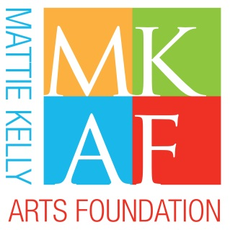

2nd

“Baubles & Bubbles”
MKAF Jewelry Pull Donation Form

Please support MKAF by donating one or multiple pieces of jewelry to the MKAF “Baubles & Bubbles” at the Ruth’s Chris Wine Walkabout. The Jewelry Pull features a varied selection of jewelry wherein participants purchase one or more chances ($50 each) to select a wrapped mystery box (minimum retail value of $50). Cash donations are also welcome.

Donor Name: (list as shown in program)

Business (if applicable):

Address:

City: State: Zip Code:

Daytime Phone: Email:

We ask that jewelry have a minimum retail value of $50
Donation deadline – November 4, 2019

Jewelry Description Retail Value

I cannot donate jewelry, but wish to contribute $

Please email form to info@mattiekellyartsfoundation.org

If you have any questions, please call 850-650-2226.

BUILDING THE FOUNDATION OF ARTS AND CULTURE IN OUR COMMUNITY!

Please submit completed form to info@mattiekellyartsfoundation.org or return to MKAF committee contact. To schedule a delivery to MKAF office, 4323 Commons Drive West, Destin, FL 32541, please call 850-650-2226. All proceeds benefit MKAF’s cultural programs and community outreach initiatives.
GIFTS TO THE MATTIE KELLY ARTS FOUNDATION MAY BE CHARACTERIZED AS CHARITABLE CONTRIBUTIONS PURSUANT TO SECTION 162 OF THE IRS CODE. A COPY OF THE FOUNDATION’S REGISTRATION AND FINANCIAL INFORMATION MAY BE OBTAINED FROM THE DIVISION OF CONSUMER AFFAIRS BY CALLING TOLL-FREE (800-435-7352) WITHIN THE STATE. REGISTRATION DOES NOT IMPLY ENDORSEMENT, APPROVAL OR RECOMMENDATION BY THE STATE.

