Click on Organizations
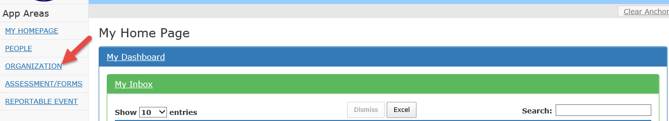

- Highlight organization name
- Click Anchor
- Click Assessment/Forms
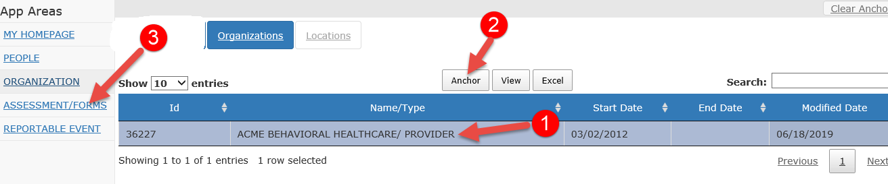

Click Add
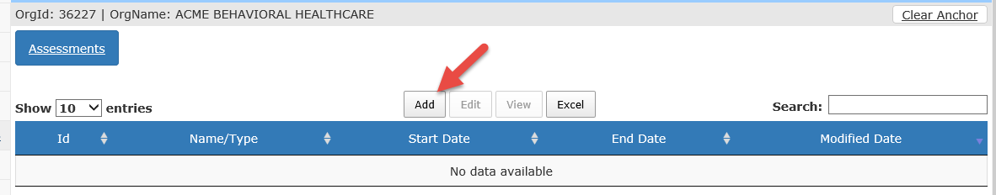

Start Date: Defaults to system date
End Date: leave blank
Highlight Assessment Type: Adding/Editing/Ending User’s/Assessment
Organization: Defaults to your agency
Title: Type in what you want done
- Adding a user
- Editing a user (describe in comment box)
- End a user
Description: Leave Blank
Click Start Assessment

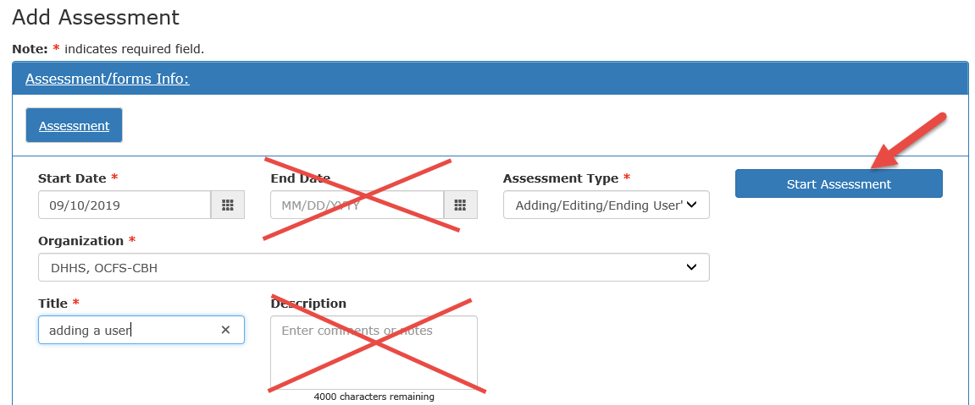

it will bring you to Tab
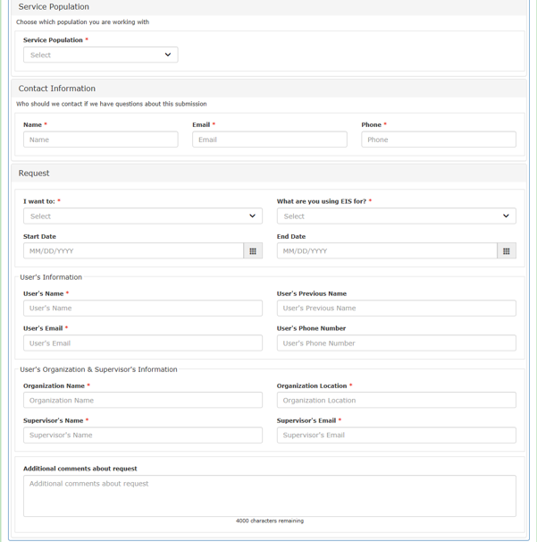

* Is required

Service Population
Service Population: choose which population you are working with, Childrens or Adults
Contact Information
Name*: Individual requesting the change
Email*: Individual’s email requesting the change
Phone Number*: Individual’s phone number requesting the change

Request
I want to *: choose from the dropdown
What are you using EIS for*: choose from dropdown
Start Date: when you want it added/edited/ended
End Date: when you want it ended
User’s Information
User’s Name*:
User’s Previous Name: users name changed due to marriage, etc…
User’s Email*:
User’s Phone Number:
User’s Organization & Supervisor’s Information
Organization Name *: Name of organization were the user is employed
Organization Location *: Location of were user is based out of
Supervisor’s Name*: Supervisor of user
Supervisor’s Email*:
Additional comments about request: Any additional comments you would like to add and be sure if you are requesting edits describe them here.

Click the “Submit All Pages” at bottom of form (this sends the form to EIS administrative staff)
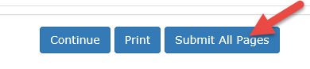

You will get success message
